Name: Maloth Aditya

Roll No.: 120CS0124

**Q1**.

**Domain Code:**

(define (domain trucking)

(:requirements :strips :negative-preconditions :equality)

(:predicates

    (CITY ?x)

    (TRUCK ?x)

    (PACKAGE ?x)

    (is-empty ?x)

    (at-city ?x ?y)

    (carry ?x ?y)

)

(:action load

    :parameters (?x ?y ?z)

    :precondition (and

        (PACKAGE ?x) (TRUCK ?y) (CITY ?z)

        (at-city ?x ?z)

        (at-city ?y ?z)

        (is-empty ?y)

    )

    :effect (and

        (not (is-empty ?y))

        (carry ?y ?x)

        ; (not (at-city ?x ?z))

    )

)

(:action unload

    :parameters (?x ?y ?z)

    :precondition (and

        (PACKAGE ?x) (TRUCK ?y) (CITY ?z)

        ; (not (at-city ?x ?z))

        (at-city ?y ?z)

        (not (is-empty ?y))

        (carry ?y ?x)

    )

    :effect (and

        (is-empty ?y)

        (at-city ?x ?z)

    )

)

(:action drive

    :parameters (?x ?y ?z ?p1)

    :precondition (and

        (CITY ?x) (CITY ?y) (TRUCK ?z) (PACKAGE ?p1)

        (at-city ?z ?x)

        (carry ?z ?p1)

        (at-city ?p1 ?x)

        (not (at-city ?p1 ?y))

    )

    :effect (and

        (at-city ?z ?y)

        (not (at-city ?z ?x))

        (at-city ?p1 ?y)

        (not (at-city ?p1 ?x))

    )

)

)

**Problem Code:**

(define (problem problem_name) (:domain trucking)

(:objects truck1 truck2 package1 package2 package3 package4 package5 package6 package7 package8 city1 city2)

(:init

    (TRUCK truck1) (TRUCK truck2)

    (CITY city1) (CITY city2)

    (PACKAGE package1) (PACKAGE package2)

    ; (PACKAGE package3) (PACKAGE package4)

    (PACKAGE package5) (PACKAGE package6)

    ; (PACKAGE package7) (PACKAGE package8)

    (at-city package1 city1) (at-city package2 city1)

    ; (at-city package3 city1) (at-city package4 city1)

    (at-city package5 city2) (at-city package6 city2)

    ; (at-city package7 city2) (at-city package8 city2)

    (is-empty truck1) (is-empty truck2)

    (at-city truck1 city1)

    (at-city truck2 city2)

)

(:goal (and

    (at-city package1 city2) (at-city package2 city2)

    ; (at-city package3 city2) (at-city package4 city2)

    (at-city package5 city1) (at-city package6 city1)

    ; (at-city package7 city1) (at-city package8 city1)

))

)

**OUTPUT**:

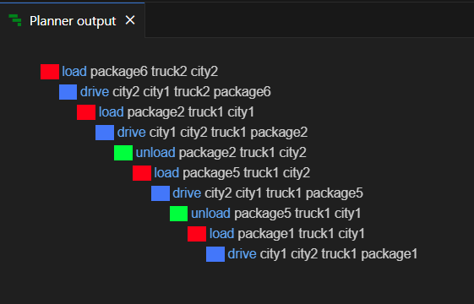

**Q2**.

**Domain Code:**

(define (domain blocksOnTable)

(:requirements :strips :negative-preconditions :equality)

(:predicates

        (BLOCK ?x)

        (TABLE ?x)

        (TOPFREE ?x)

        (ONTOPOF ?x ?y)

)

(:action moveBlockFromToTopOfTable

    :parameters (?x ?y ?z)

    :precondition (and

        (BLOCK ?x)

        (TABLE ?z)

        (TOPFREE ?x)

        (TOPFREE ?z)

        (ONTOPOF ?x ?y)

    )

    :effect (and

        (TOPFREE ?y)

        (not (ONTOPOF ?x ?y))

        (ONTOPOF ?x ?z)

    )

)

(:action moveBlockFromToTopOfBlock

    :parameters (?x ?y ?z)

    :precondition (and

        (BLOCK ?x)

        (BLOCK ?z)

        (TOPFREE ?x)

        (TOPFREE ?z)

        (ONTOPOF ?x ?y)

    )

    :effect (and

        (TOPFREE ?y)

        (not (TOPFREE ?z))

        (not (ONTOPOF ?x ?y))

        (ONTOPOF ?x ?z)

    )

)

)

**Problem Code:**

(define (problem arrangeBlocks) (:domain blocksOnTable)

(:objects blockA blockB blockC blockD table)

(:init

    (BLOCK blockA)

    (BLOCK blockB)

    (BLOCK blockC)

    (BLOCK blockD)

    (TABLE table)

    (ONTOPOF blockA table)

    (ONTOPOF blockC table)

    (ONTOPOF blockB blockC)

    (ONTOPOF blockD blockB)

    (TOPFREE blockD)

    (TOPFREE blockA)

    (TOPFREE table)

)

(:goal (and

    (ONTOPOF blockD table)

    (ONTOPOF blockC blockD)

    (ONTOPOF blockB blockC)

    (ONTOPOF blockA blockB)

    (TOPFREE blockA)

))

)

**OUTPUT**:

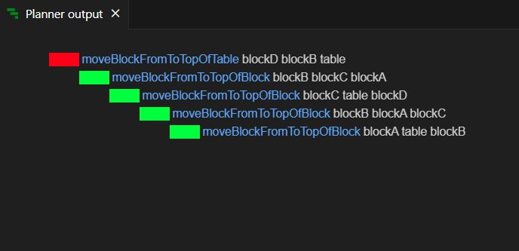

**Q3.**

**Domain Code:**

(define (domain problem3)

(:requirements :negative-preconditions :equality)

(:predicates

    (LOCATION ?x)

    (MAGICALOBJECTS ?x)

    (HORCRUXES ?x)

    (ENEMY ?x)

    (HARRY ?x)

    (HAS ?x)

    (BROOM ?x)

    (WAND ?x)

    (FANG ?x)

    (SWORD ?x)

    (LOCKET ?x)

    (CUP ?x)

    (ROOMOFREQUIREMENTS ?x)

    (FORESTOFDEAN ?x)

    (CHAMBEROFSECRETS ?x)

    (OLIVANDERS ?x)

    (MINISTRYOFMAGIC ?x)

    (VAULT ?x)

    (FORBIDDENFOREST ?x)

    (LOCKETDESTROYED)

    (CUPDESTROYED)

    (ENEMYDEAD)

    (AT ?x)

    (DEAD ?x)

)

(:action KILLENEMY

    :parameters (?x ?y ?z)

    :precondition (and

        (AT ?x)

        (FORBIDDENFOREST ?x)

        (not (DEAD ?z))

        (ENEMY ?z)

        (HAS ?y)

        (WAND ?y)

        (LOCKETDESTROYED)

        (CUPDESTROYED)

    )

    :effect (DEAD ?z)

)

(:action DESTROYLOCKET

    :parameters (?x ?y)

    :precondition (and

        (AT ?x)

        (MINISTRYOFMAGIC ?x)

        (not (LOCKETDESTROYED))

        (HAS ?y)

        (SWORD ?y)

    )

    :effect (LOCKETDESTROYED)

)

(:action DESTROYCUP

    :parameters (?x ?y)

    :precondition (and

        (AT ?x)

        (VAULT ?x)

        (not (CUPDESTROYED))

        (HAS ?y)

        (FANG ?y)

    )

    :effect (CUPDESTROYED)

)

(:action PICKUPWAND

    :parameters (?x ?y)

    :precondition (and

        (AT ?x)

        (OLIVANDERS ?x)

        (not (HAS ?y))

        (WAND ?y)

    )

    :effect (HAS ?y)

)

(:action PICKUPFANG

    :parameters (?x ?y)

    :precondition (and

        (AT ?x)

        (CHAMBEROFSECRETS ?x)

        (not (HAS ?y))

        (FANG ?y)

    )

    :effect (HAS ?y)

)

(:action PICKUPSWORD

    :parameters (?x ?y)

    :precondition (and

        (AT ?x)

        (FORESTOFDEAN ?x)

        (not (HAS ?y))

        (SWORD ?y)

    )

    :effect (HAS ?y)

)

(:action PICKUPBROOM

    :parameters (?x ?y)

    :precondition (and

        (AT ?x)

        (ROOMOFREQUIREMENTS ?x)

        (not (HAS ?y))

        (BROOM ?y)

    )

    :effect (HAS ?y)

)

(:action GOFROMTO

    :parameters (?x ?y ?z)

    :precondition (and

        (AT ?x)

        (not (AT ?y))

        (HAS ?z)

        (BROOM ?z)

    )

    :effect (and

        (AT ?y)

        (not (AT ?x))

    )

)

)

**Problem Code:**

(define (problem problem_name) (:domain problem3)

(:objects sword fang wand harry broom locket cup forestofdean chamberofsecrets roomofrequirements olivanders enemy ministryofmagic vault forbiddenforest

)

(:init

    (BROOM broom)

    (SWORD sword)

    (WAND wand)

    (FANG fang)

    (ROOMOFREQUIREMENTS roomofrequirements)

    (FORESTOFDEAN forestofdean)

    (CHAMBEROFSECRETS chamberofsecrets)

    (OLIVANDERS olivanders)

    (MINISTRYOFMAGIC ministryofmagic)

    (VAULT vault)

    (FORBIDDENFOREST forbiddenforest)

    (ENEMY enemy)

    (AT roomofrequirements)

)

(:goal (DEAD enemy))

)

**OUTPUT:**

